ELEC 5150/6150 Information Security

LAB 5 REPORT
Xiao Lin & Yuanqi Chen

Abstract
In this lab we are going to practice how to generate the parameter set for ECDH key agreement algorithm as well as the key exchange. Beside in first part we also compare the performance of different length of bit for DH and different curve of ECDH. Additionally we use UDP and TCP to implement to party to practice the key exchange.

Introduction
Diffie-Hellman protocol is invented by Diffie and Hellman, by using DH Alice and Bob can have a share-secrete without really share a secrete, the basic of DH is that given 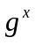 mod p it is mathematically hard to extract x and given mod p and 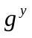mod p it is mathematically hard to compute 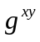 mod p unless x or y is given.so the DH is safe. And what the both parties need is to have a same parameter set and show their public key so they can generate a shared secrete. What we should draw attention to is that DH do not offer encryption.

Design
Step 1
In this step we are going to compare the performance of different length of bit for DH and the performance of different curve of ECDH. After the comparison we implement the key exchange.

First we test the parameter of DH.
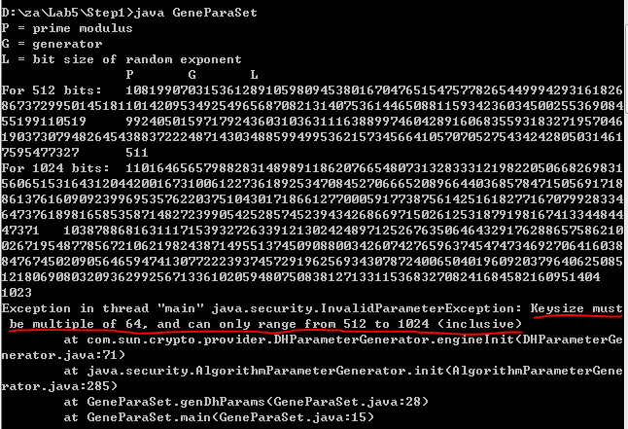
We test 512 1024 2048 and 4096 bits, what we can see in the exception information is that the key size of DH parameter have a limitation using the method of sun provider.
And what will happen if we use the provider of RSA?
Now we have a test
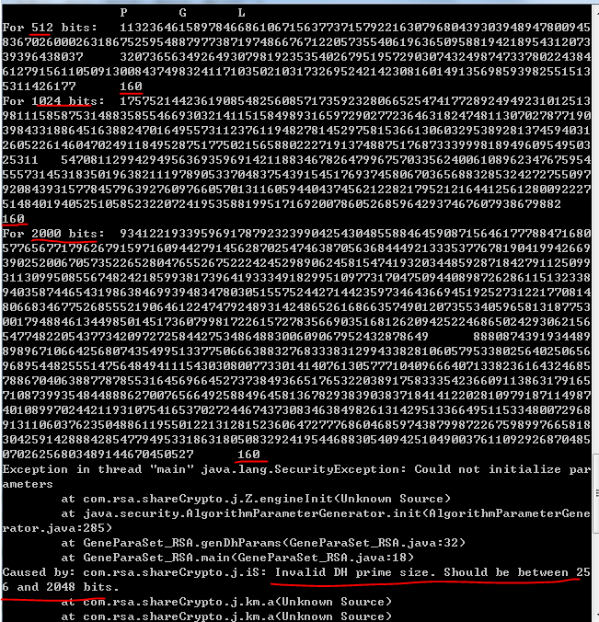
As we can see the size also have a limitation but it does not matter of the size is a multiple of 64. And the number we enter is the size of DH prime, the return number is the size of L. What is interesting is that the L is always same but I have not find the reason yet.

And now we are going to test the performance of different curve, we can find the curve name in the slides Chapter 22 Page 76.

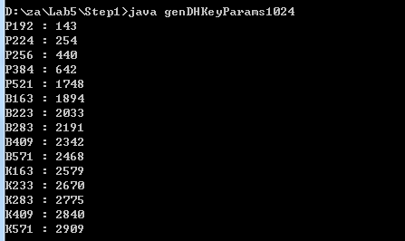

And now we are going to generate public key, private key, shared secrete as well as AES-256 key and IV for both parties.

Here is the printout information:
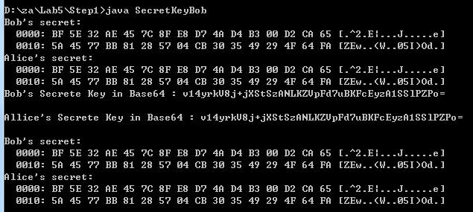
The first 12 bytes is IV and the others are AES-256 key
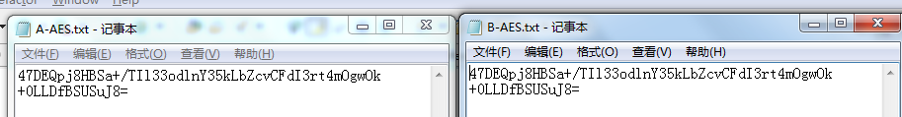
The public key and private key:
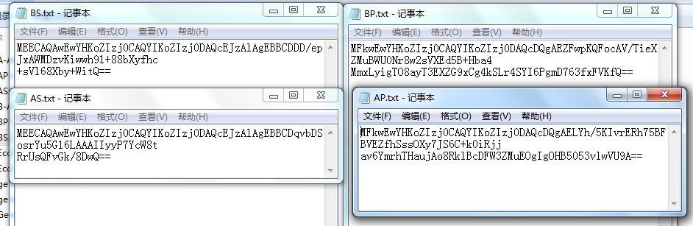Step 2
In this step we are going to do what we have done in step 1 but we do this by using UDP for Bob and Alice.
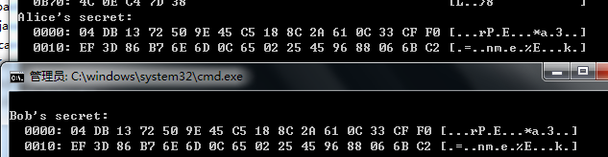
Their shared secret which is generated by themselves.
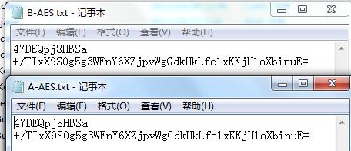
Their IV and AES-256 key to encrypt and decrypt file.

This part is their handshake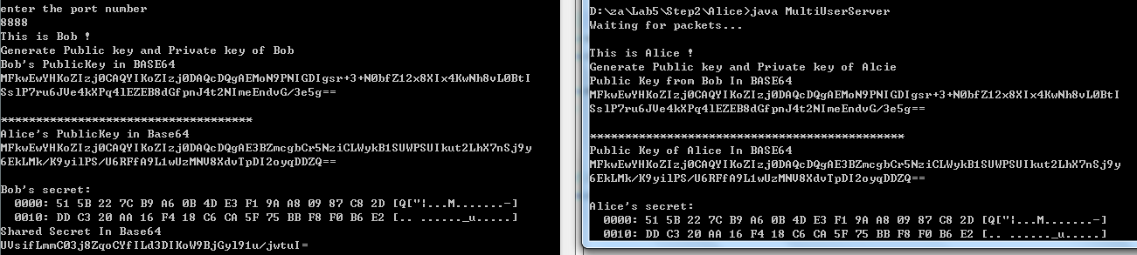

First Bob send his Public key to Alice. After Alice have received the public key, Alice generate her public key and send the public key back to Bob. And both Bob and Alice use the others' public key to generate the shared secrete, because they have the same key, so they will have the same secrete.

Step 3
In this step we are going to deliver encrypted file from Bob to Alice, and Alice will decrypt it.
Ciphertext and plaintext in command window
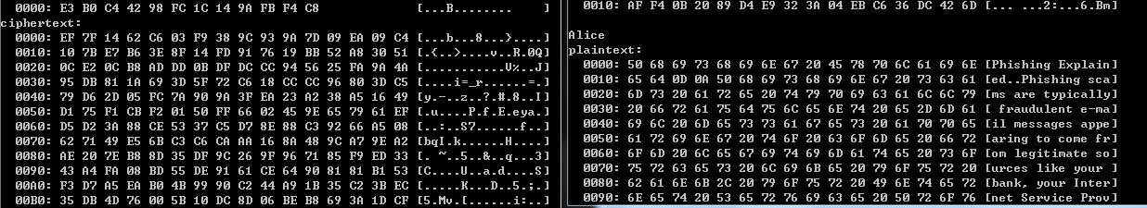

The IV and key, plaintext and de-cipher text
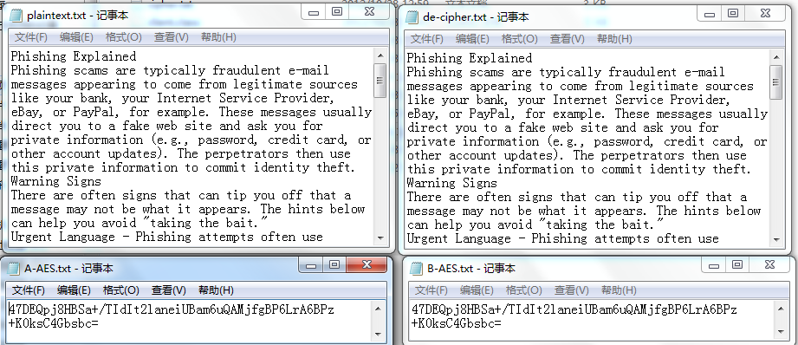

Step 4
In this we are going to do what we have done in step 2 and step 3, but in this step we will use TCP.

Bob send encrypted file to Alice, Alice decrypt is and send back
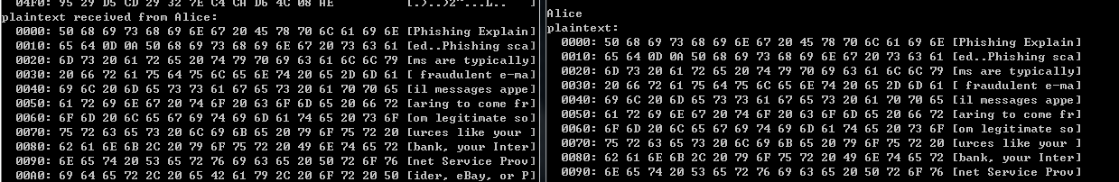

The IV, key ,plaintext and the de-cipher text
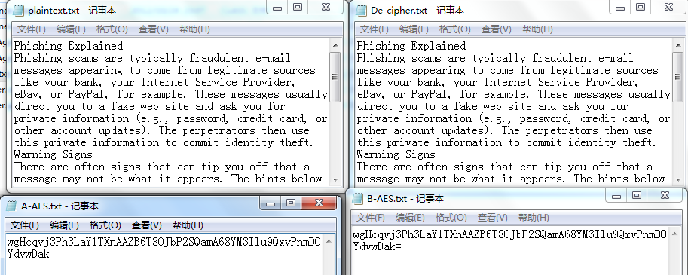

Result
All of the exercise in this lab have been completed. And in the first step we find a interesting problem about the provider of RSA in generating the parameter set of DH, after doing this lab we get a more straight understanding of DH key agreement.

Conclusion
All of the exercise have been completed, after go thought all of the exercises we have a better understanding of DH key agreement algorithm.

References
- Example codes and sample solutions from Dr.Wu
- DH key agreement algorithm
http://exampledepot.com/egs/javax.crypto/KeyAgree.html
- RSA BSAFE SHARE, ECDH Key Agreement
http://developer-content.emc.com/docs/rsashare/share_for_java/1.1/dev_guide/group__JCESAMPLES__KEYAGREE__KDH.html
- Other web site
http://www.dreamincode.net/forums/topic/256565-implementation-of-ecdh/
http://docs.oracle.com/javase/tutorial/networking/sockets/definition.html

